API Automation

Rest-Assured Framework :
For validating various things from response we use Rest Assured Framework.
It follows Behaviour Driven Development ie: given when then approach.
- Given part describes the state before you begin the behaviour that you will specify in your scenario.In this part you will pass query parameters,cookie map ,content type(XML or JSON) etc.
- When part describes the behaviour that you specify,like hitting a url(API).
- Then section describes the changes you expect due to the specified behaviour.We usually include the assertion part here.

Example of behaviour driven development :
given()
.cookies(cookieMap)
.contentType("application/json")
.queryParam("json", postData)

.when()
.get(url);

**Note :Use the following dependency in your Maven project’s POM for including Rest Assured library.

<dependency>
<groupId>com.jayway.restassured</groupId>
<artifactId>rest-assured</artifactId>
<version>2.9.0</version>
</dependency>
Rest assured works with both XML and JSON.
Hybrid Framework :
This involves hitting APIs,accessing the response and then validating this response from the UI
Retrieving the API URLs through Charles proxy :

Navigate to the LMS site and observe the charles proxy

Login API:
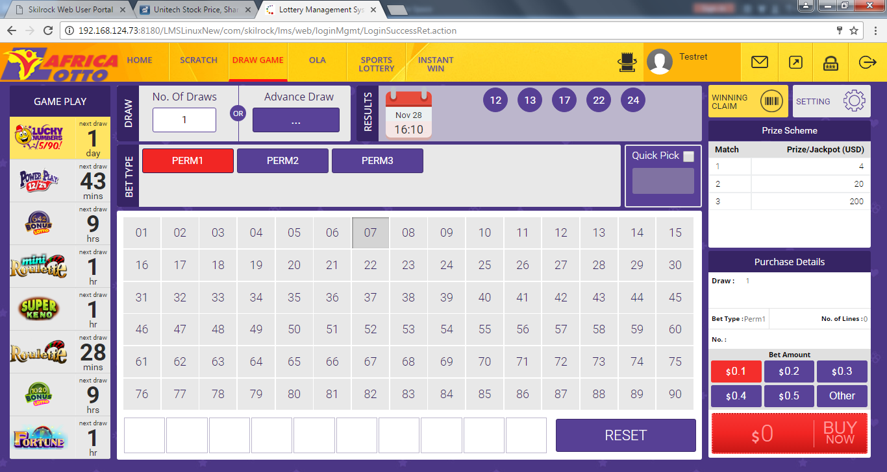

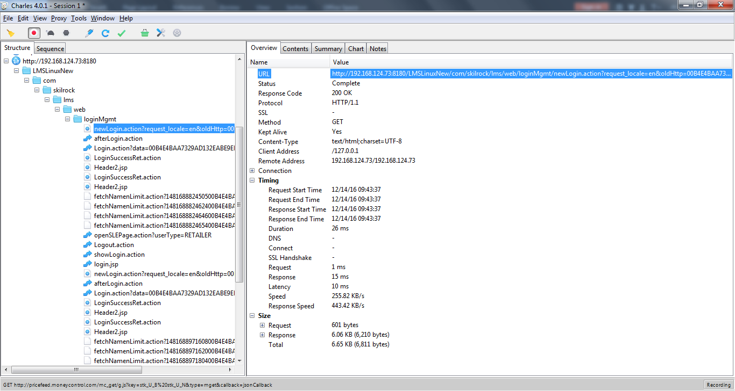

Fetch SLE API:
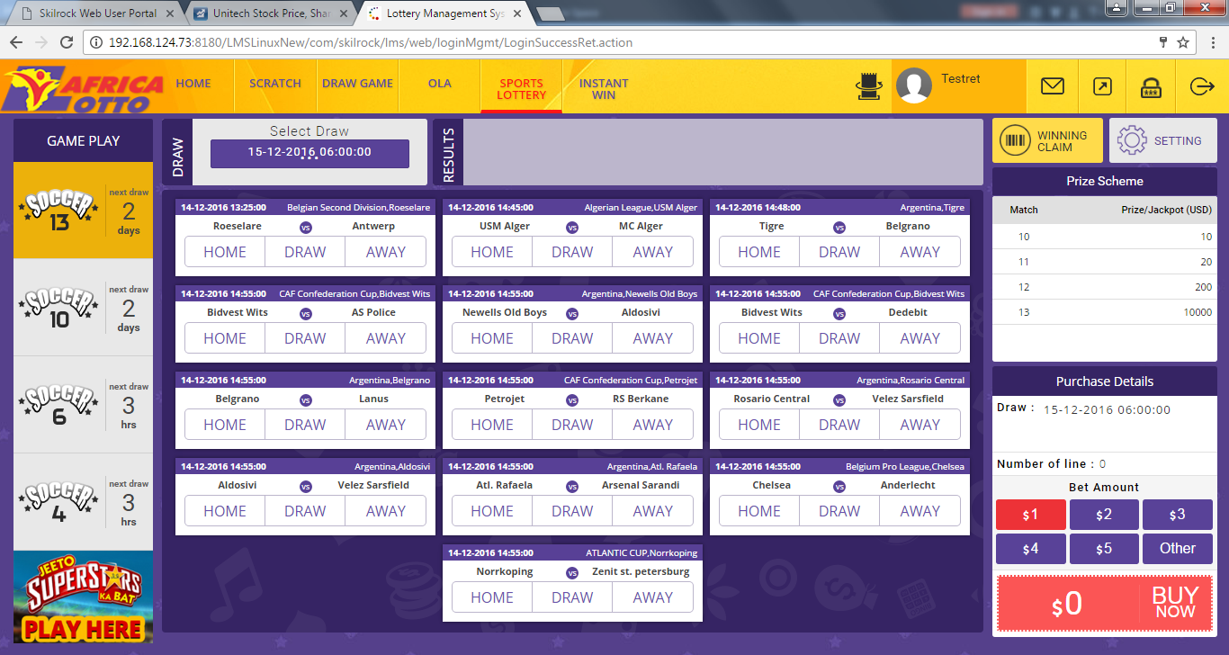

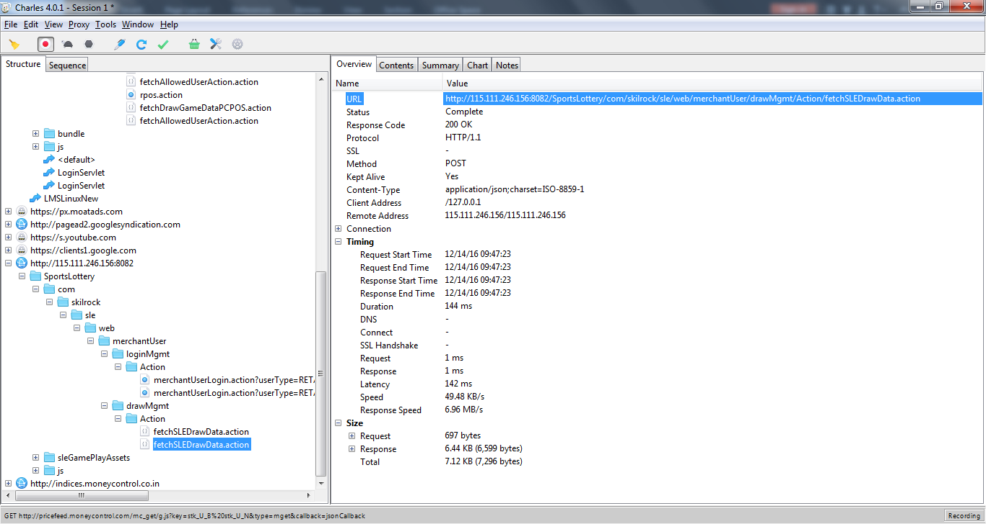

Checking Response from Fetch SLE Draw Data under text tab in charles proxy :

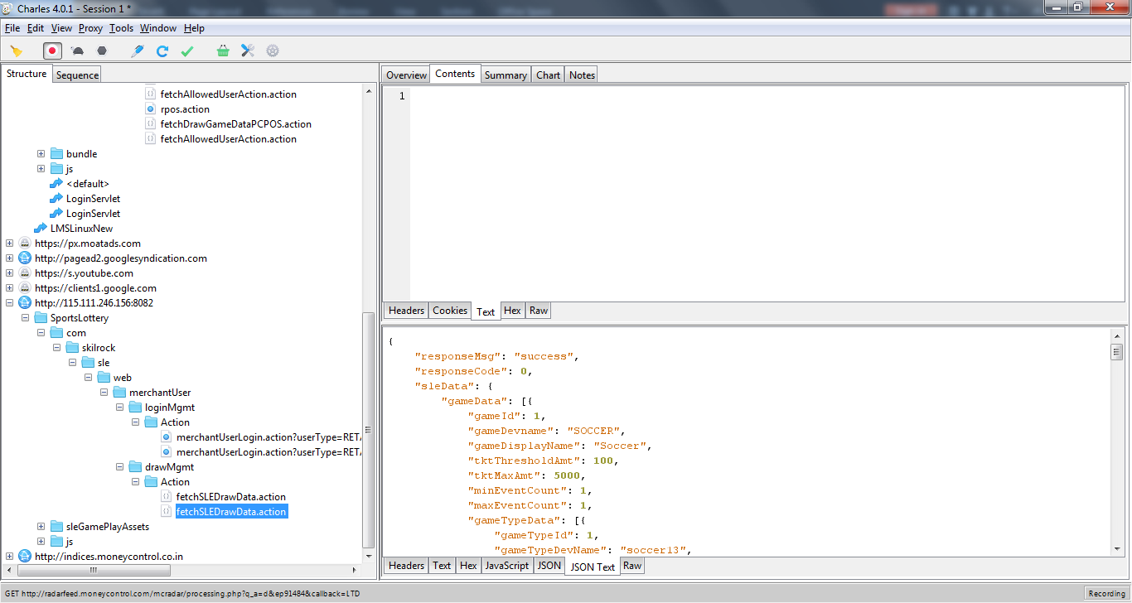

Accessing some of the data from the API response:

Suppose we want to access value for a field called ticketNo in the
response which is present under another field with key tktData
We can retrieve the ticketNo with the following code:
String temp=response.jsonPath().get("tktData.ticketNo").toString();
Refernces for JSONPath: http://goessner.net/articles/JsonPath/

Hitting the API and encapsulating the response :
Minimum requirement for generating a response from an API is to pass a queryParameter which we accomplish through the following statement:
response =given()
.contentType("application/json")
.queryParam("requestData", inputData)
.get(url1);

Where requestData is the key name for the request parameter passed before hitting the API. This requestData can be retrieved from charles proxy

Steps to see how requestData(in json form) looks like in charles :

1.Select at least one games from all the 13 events present under Soccer13

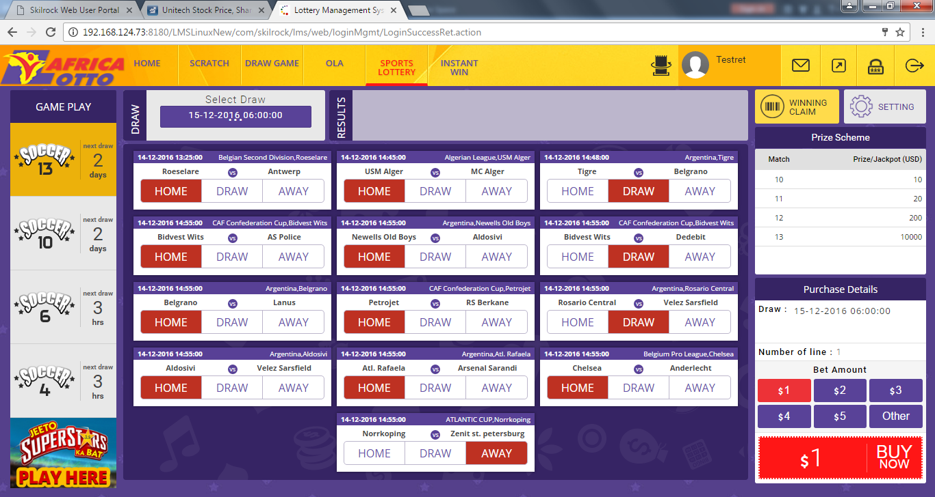

Perform a sale by clicking the buy button
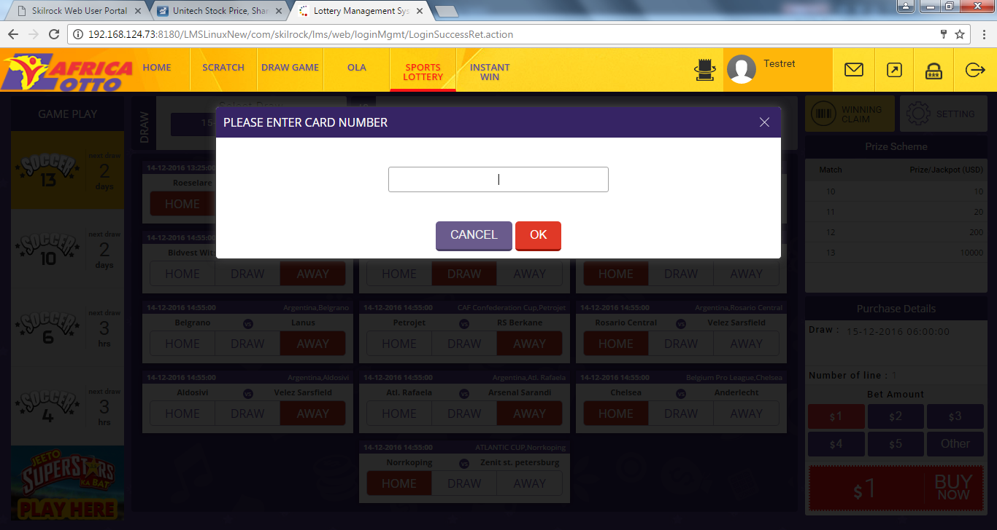

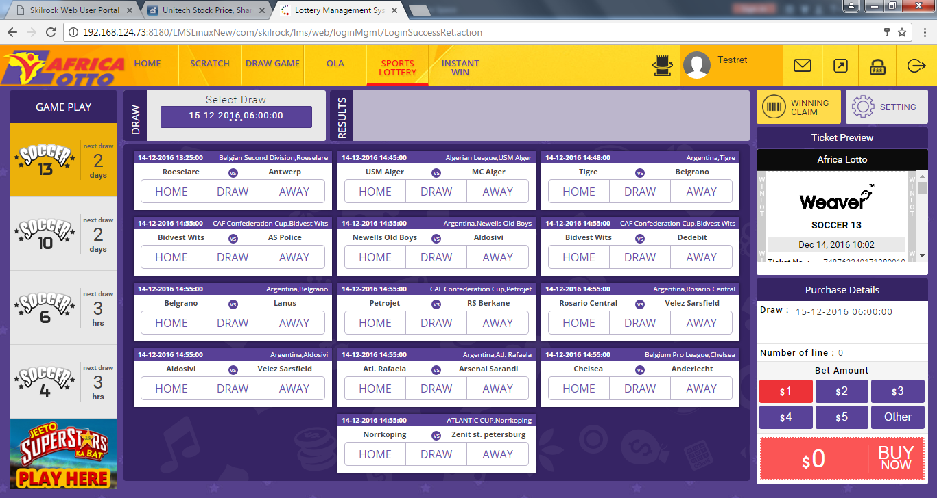

Check charles proxy to see which API got hit for performing soccer 13 sale :

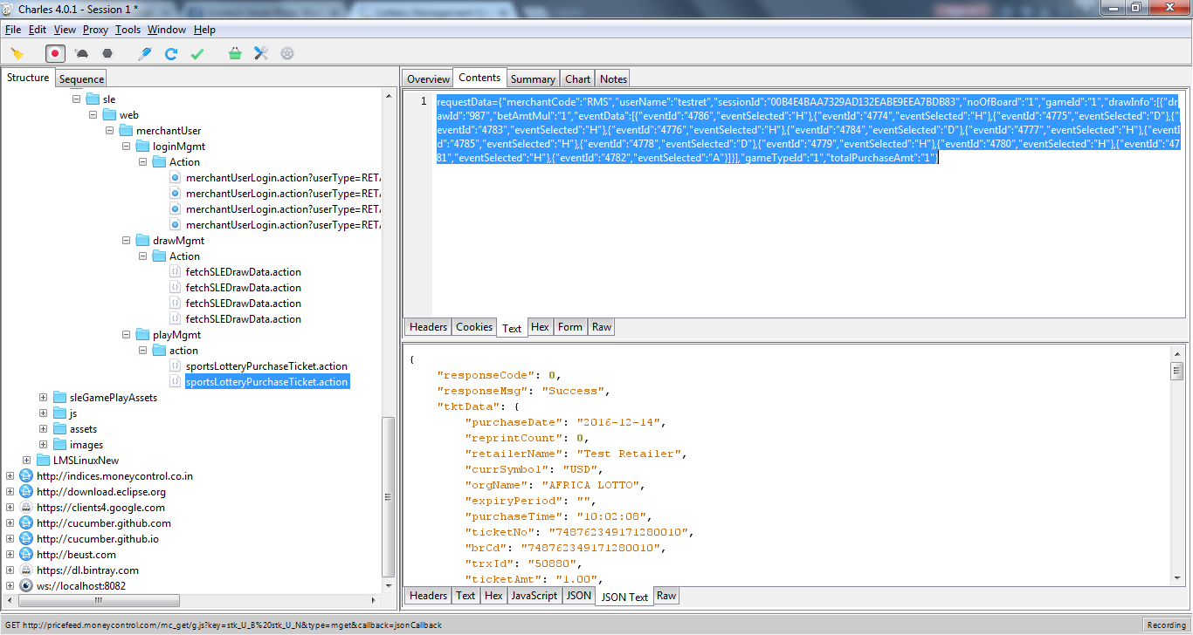

The above highlighted portion represents the requestData

requestData={"merchantCode":"RMS","userName":"testret","sessionId":"00B4E4BAA7329AD132EABE9EEA7BDB83","noOfBoard":"1","gameId":"1","drawInfo":[{"drawId":"987","betAmtMul":"1","eventData":[{"eventId":"4786","eventSelected":"H"},{"eventId":"4774","eventSelected":"H"},{"eventId":"4775","eventSelected":"D"},{"eventId":"4783","eventSelected":"H"},{"eventId":"4776","eventSelected":"H"},{"eventId":"4784","eventSelected":"D"},{"eventId":"4777","eventSelected":"H"},{"eventId":"4785","eventSelected":"H"},{"eventId":"4778","eventSelected":"D"},{"eventId":"4779","eventSelected":"H"},{"eventId":"4780","eventSelected":"H"},{"eventId":"4781","eventSelected":"H"},{"eventId":"4782","eventSelected":"A"}]}],"gameTypeId":"1","totalPurchaseAmt":"1"}

This request data can be changed if we want to change the input/query parameter being passed to the API.

Another Example of Retrieving/Extracting Data from a Response:
Sample Response:
{
"isSuccess": true,
"refundAmount": 2,
"ticketNumber": "349962351171280290",
"gameTypeName": "Soccer 13",
"Balance": "84953.12",
"mode": "Cancel",
"cancelDateTime": "2016-12-16 12:12:11.486",
"orgName": "AFRICA LOTTO",
"currSymbol": "USD"
}
1.Retrieving organization’s name:
response.jsonPath().get(“orgName”).toString()

- Retrieving currency symbol value :
response.jsonPath().get(“currSymbol”).toString()

Another Example of Retrieving/Extracting Data from a Response:
Sample Response:
{
"responseCode": 0,
"responseMsg": "Success",
"tktData": {
"purchaseDate": "2016-12-16",
"reprintCount": 0,
"retailerName": "Test Retailer",
"currSymbol": "USD",
"orgName": "AFRICA LOTTO"
}
}
1.Retrieving reprint count:
response.jsonPath().get(“tktData.reprintCount”).toString()

Steps to getting a response:
- Make sure the cookies,content type and input data(query parameter) is mentioned in the given() part
Eg :
given()
.contentType(“application/json”)
.queryParam(key,val)
.cookies(cookie map object)
- After mentioning the given part hit the url of the api as below
.when()
.post(url)

Maintaining session via cookies:
* save the cookie during the authentication process to maintain same session throughout a given flow which requires the same session to be maintained.
Map<String,String> cookieObject=response.getCookies()
* the cookie map returned in the above step can be passed as input within the given() clause/method of the rest assured to maintain a given session.

API AUTOMATION:
This involves validating the response from the API against the Database
**Note: All the methods hitting APIs are present under PCPOSApi.java file under src/main/java/apis

**Note: All the methods involving validating response against the data from the Database can be found under ApiCommonValidationPage.java

**Note: For all other games and bet the same above flow
**Refer to Rest Assured

